Q1: Database & Collection Creation

1. Create a database named studentDB.

2. Inside it, create a collection named students

db={

students: []

}

Q2: Insert Operations Insert the following documents into the students collection: { "name": "Anshul", "age": 21, "course": "MERN", "marks": 85 } { "name": "Riya", "age": 22, "course": "Python", "marks": 90 } { "name": "Aman", "age": 20, "course": "Java", "marks": 78 } { "name": "Neha", "age": 23, "course": "MERN", "marks": 92 } { "name": "Karan", "age": 21, "course": "C++", "marks": 80

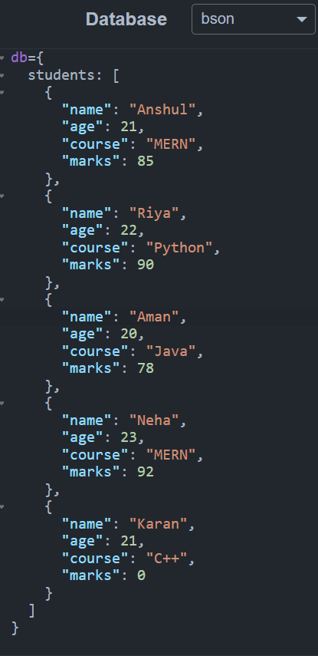

Q3: Read Operations

1. Display all students.

QUERY

db.students.find({},

{

name: 1,

course: 1

})

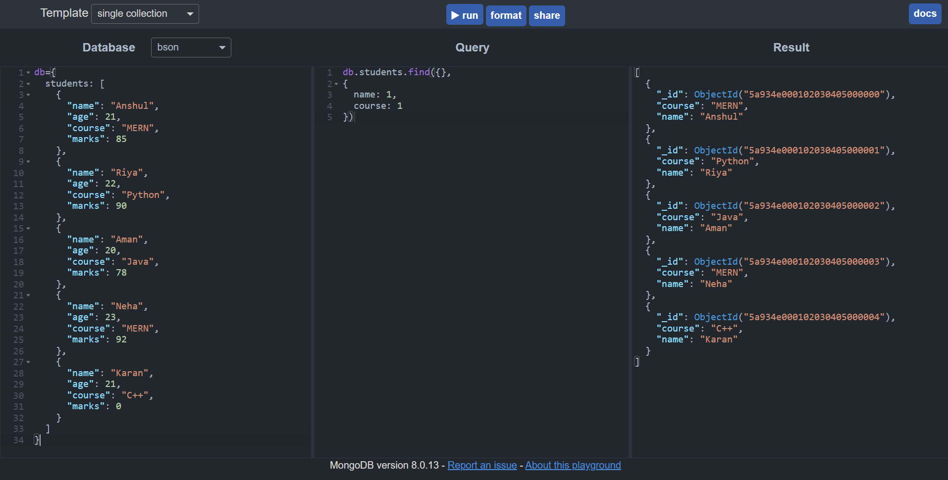

1. Display students enrolled in MERN.

QUERY

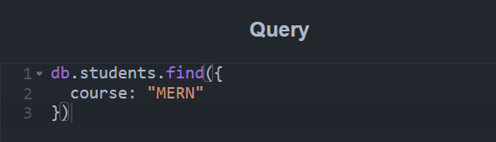

RESULT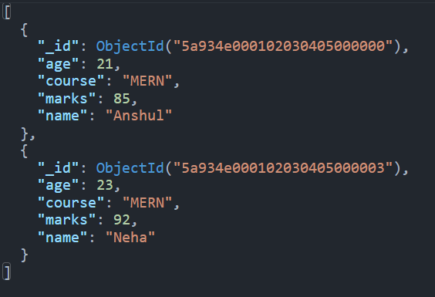

1. Find students with marks greater than 85.

query

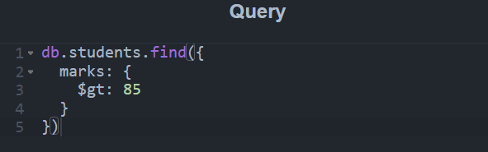

Result

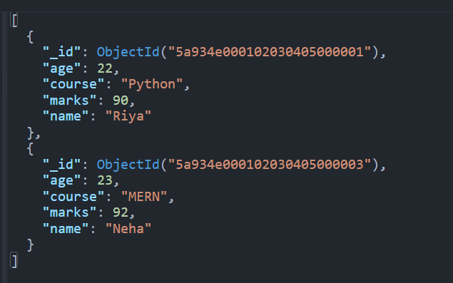

4.Find students whose age is less than 22

query

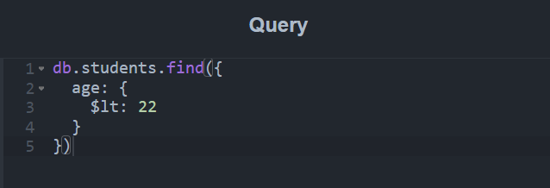 result

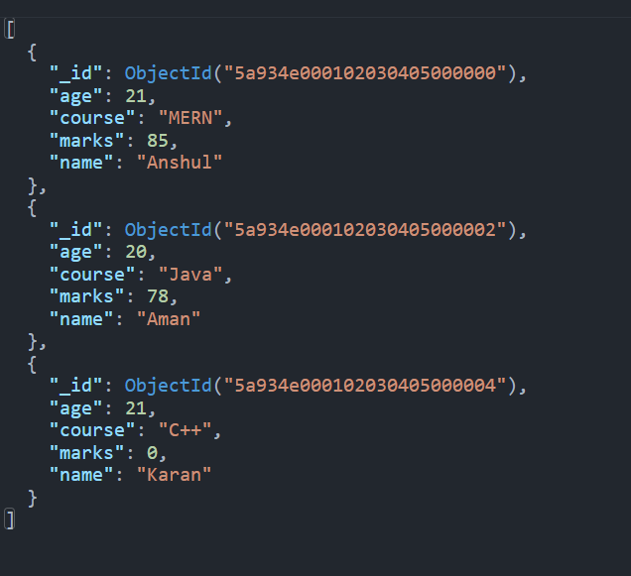

Q4: Update Operations

1. Update Aman's marks to 88

query

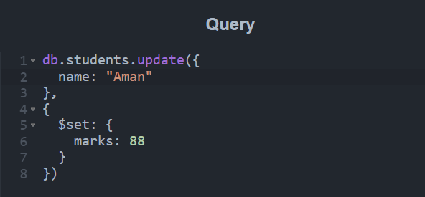

Result

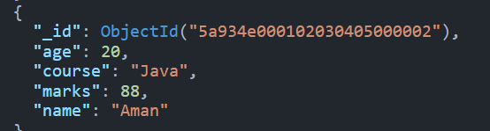

1. Increase marks by 5 for all students in the MERN course

query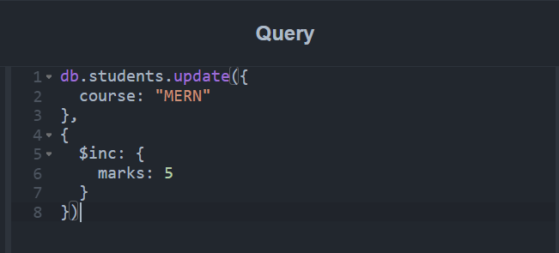

result

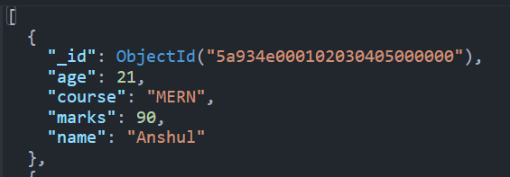

Q5: Delete Operations

1. Delete the student named Karan

query

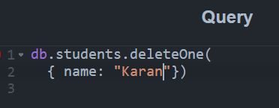

result

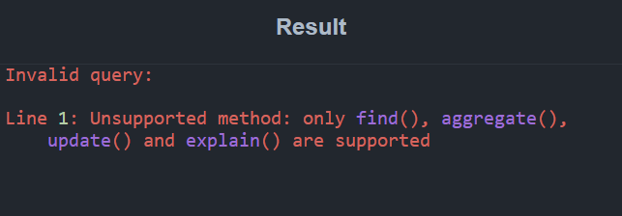

Using find()

query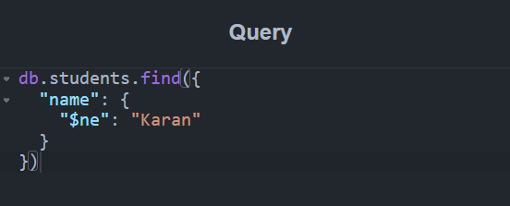

result

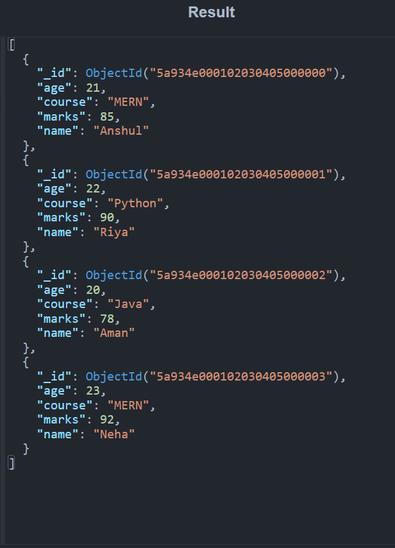

2.Delete all students with marks less than 80

query

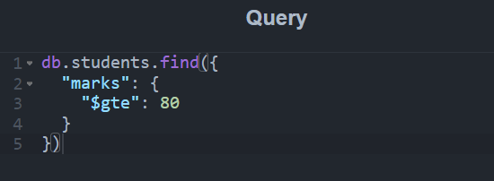

Result

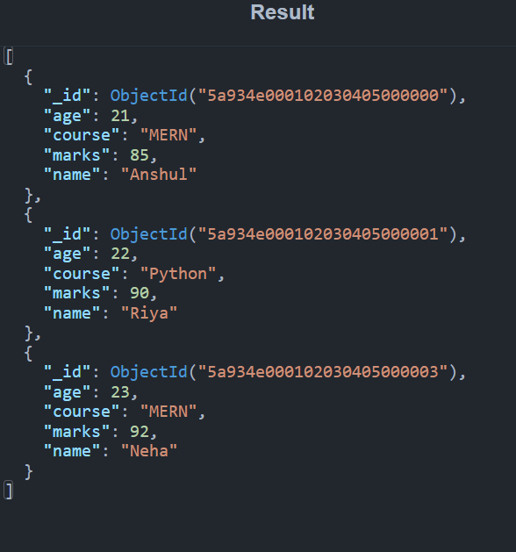

Q6: Advanced Queries

1. Count the number of students in each course

query

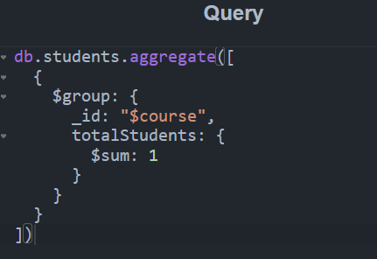

Result

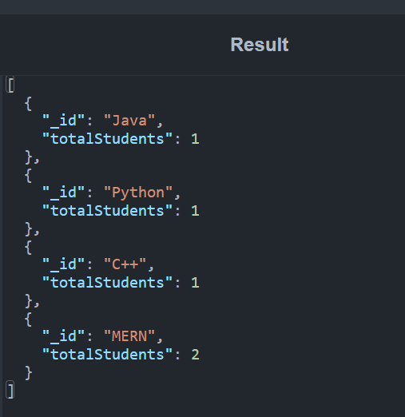

2.Sort students by marks in descending order

Query

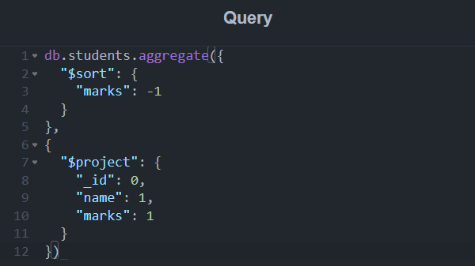

Result

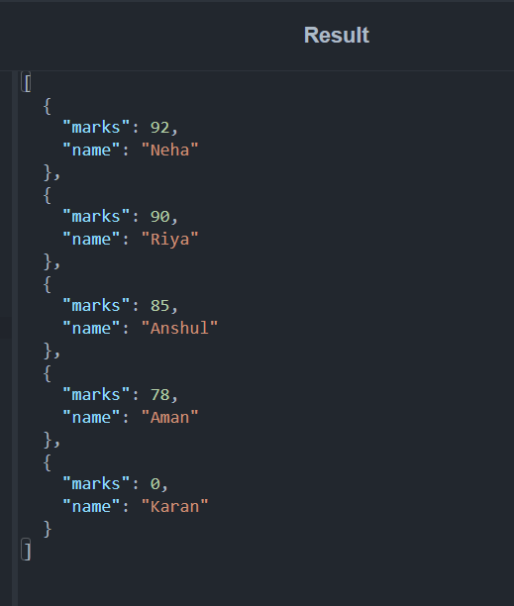

3.Find the student with the highest marks.

query

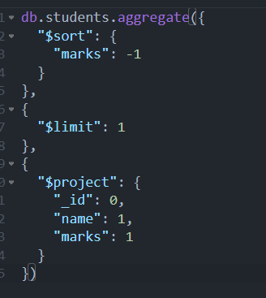

result

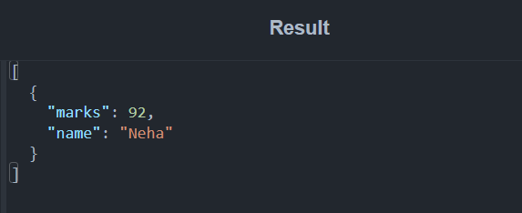

1. Display only name and marks of all students.

Query

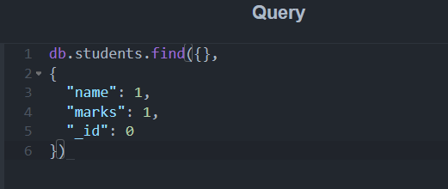

Results

